How Kaggle competitions are way different than Real World scenarios?

So basically it is like in Kaggle competitions or any other machine learning competition they set one measure and every competitor just try to optimize that parameter using any method not focussing on any other measure.

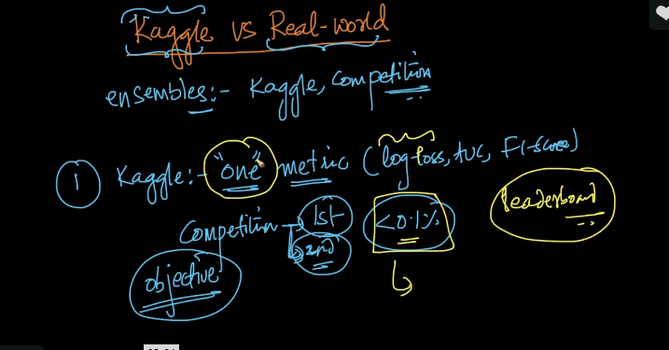

And the difference between 1st price winner and 2nd price winner is very less and in real world that may not matter.

But in real world the seen is different i.e. the person does not only focus on single metric but they have primary and secondary metric .

For example if the goal in real world is to increase sales so the task is to convert that Business metric to ML-metric of 1 or more metric that matters.

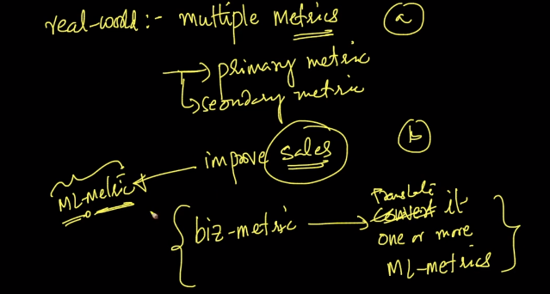

So the learning and non learnings from Kaggle are shown in below image.

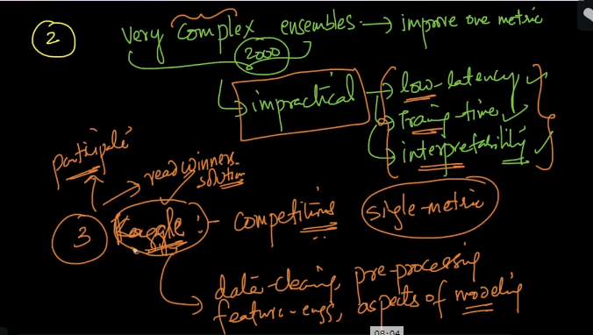

**Comments:**

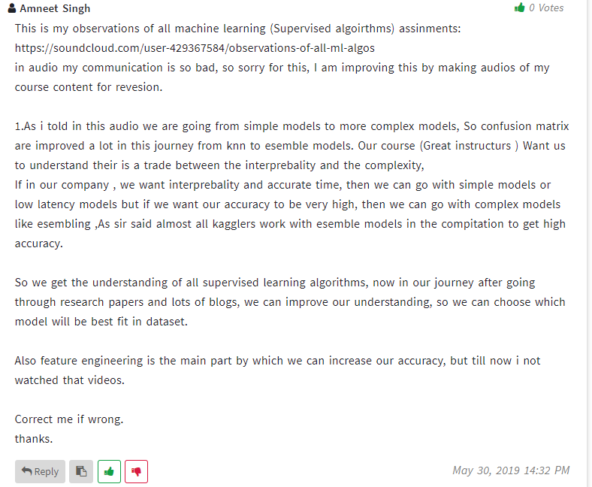



Interesting insight to read:

<https://towardsdatascience.com/ask-me-anything-session-with-a-kaggle-grandmaster-vladimir-i-iglovikov-942ad6a06acd>